Entrance Exam Requirements
TEAS Version 7 – In-person exams only. Offered here on campus. May be from another site if it is in person. No online TEAS results accepted.
How to Register for the TEAS Exam: ATI TEAS Exam | TEAS Prep | TEAS Registration | ATI
For: All Arlington Career Institute testers
1) Click on In-Person Testing – Register for In-Person TEAS
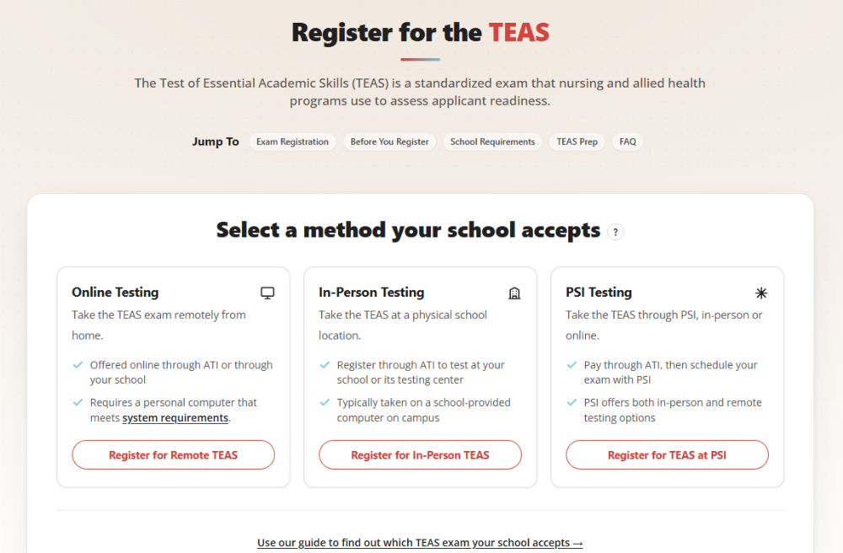
2) Search by: School Name, add State, and scroll to Arlington Career Institute. Click SEARCH.
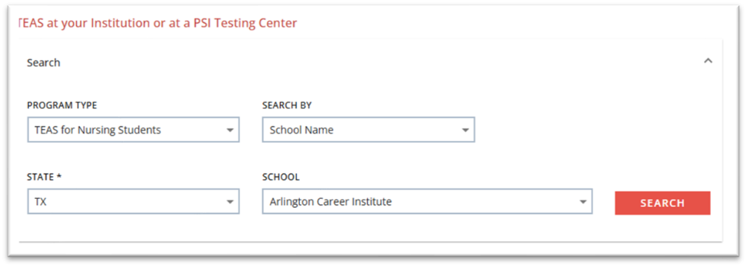

3) Find the date and time that works best for you and Click SELECT.
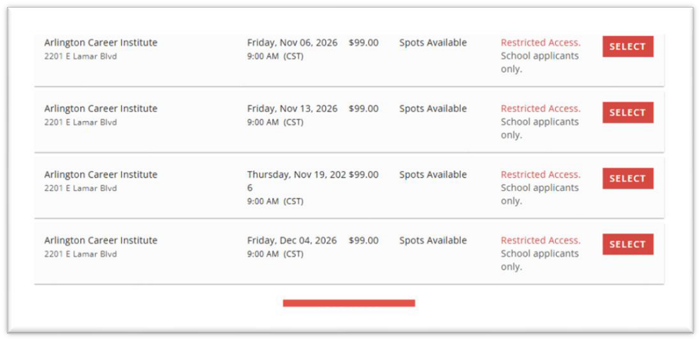

4. Read the Registration Details and FAQs. Then click CONTINUE REGISTRATION. You will be directed to a page where TEAS study resources are made available. You can click to purchase or click on “No thanks.” Ensure that you have selected the date that you want. Click PROCEED TO CHECKOUT for payment.
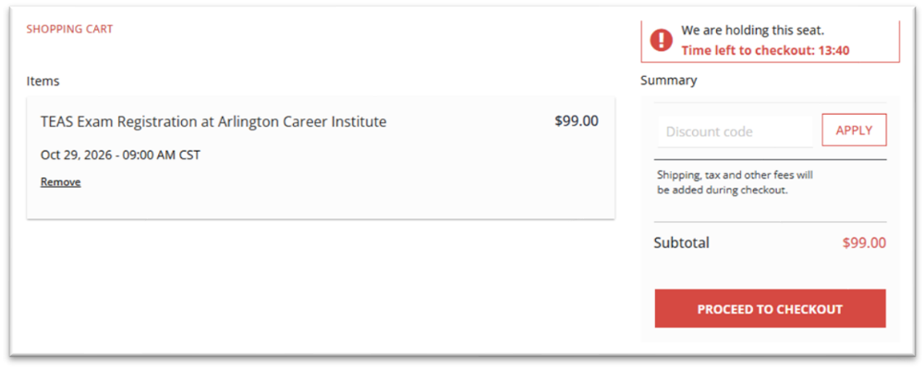

FAQs
I already took the HESI A2. Will you accept those results? Yes, for a limited time, the HESI A2 will be accepted in place of TEAS. Must have been taken no earlier than October 2024.
Do you offer any prep material or courses? No. These are available at your own expense. Information is on the ATI website.
What are the minimum acceptable scores? You must achieve a 75% average of these three categories – Reading, Math, English/Language Usage.
How many times can I take the TEAS? Two times in a one-year period. If you want a third attempt in the following year, you will have to see the VN Program Director for a review and study plan.
How long do I have to wait between attempts? You must wait 30 days.

